**SIMPLE TODO LIST**

PROJECT DOCUMENTATION

**WHAT DOES IT DO?**

Benefit from the seamless CRUD operations (Create, Read, Update, Delete) provided by TODO LIST Adding new tasks, reading details, updating them, or deleting completed tasks is a smooth process the system ensures a hassle-free experience, saving you time and it also introduces a soft delete feature that allows you to archive tasks instead of permanently deleting them. This added flexibility ensures you can review and restore tasks if needed, maintaining an organized task list while providing peace of mind.

**REQUIREMENTS:**

* **NODEJS -** a JavaScript runtime environment that will allow us to run JavaScript code on the server-side.
* **MYSQL -** an open-source relational database management system (RDBMS) that will be used for storing and managing our system data.
* **WEB BROWSER -** a software application that allows users to access and view websites.

**INSTALLATION INSTRUCTIONS**

1. Clone the repository:
   1. git clone https://github.com/marcov4623/TODO.git
2. Install dependencies:
   1. Open command prompt and go to your project directory;
   2. Then type npm install on terminal
3. Start the application:
4. Open command prompt and go to your project directory;
5. Type npm start on terminal
6. Open your browser and go to http://localhost:3001
7. Configure the database:
8. You can go to http://localhost:3001/config to configure the database connection
9. The app will create its own database.

**THE APP AND HOW TO USE IT:**

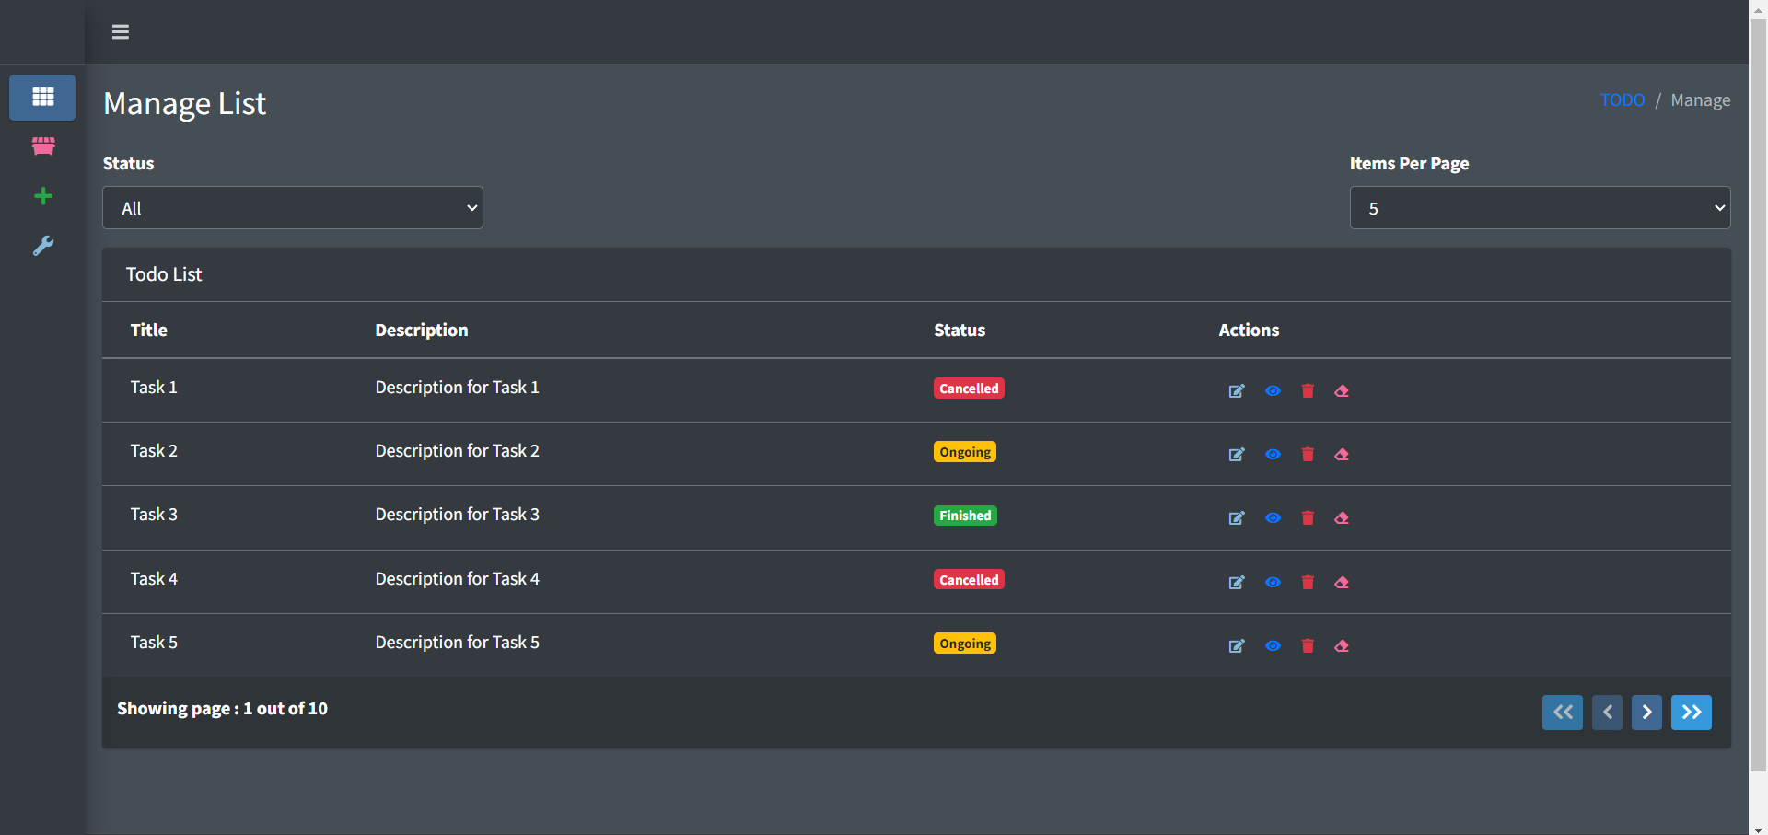

* **ADD TASKS**
  + Click the add task button by the side navigation and a pop-up will be shown containing our add tasks form  
    . 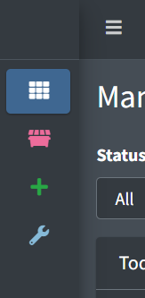 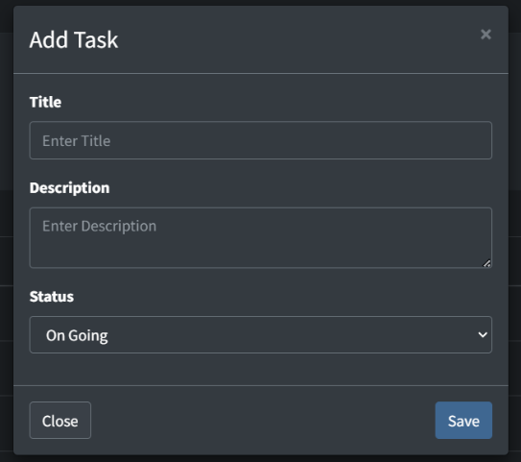
  + Fill Up the fields and click the save buttons.
* **EDIT TASKS**
  + Click the edit task button placed along with the row of task data in the actions columns, then there will be a pop-up showing the current data of your task  
    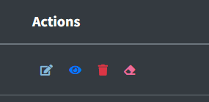 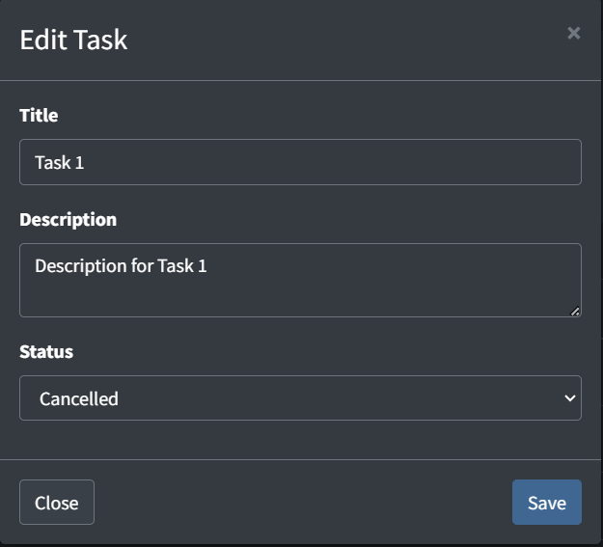
  + Fill Up the fields and click the save buttons.
* **DELETE, SOFT DELETE AND RESTORE TASKS**
  + Click the delete/soft delete task button placed along with the row of task data in the actions column, then there will be a pop-up asking for the confirmation.  
    .  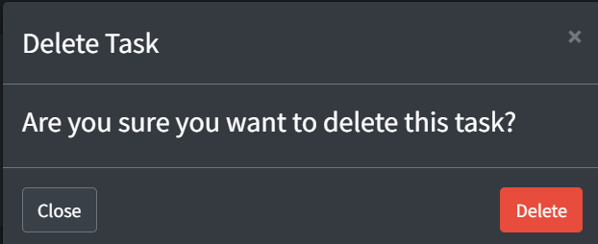
  + If you are sure on deleting the data just click the delete button.
  + If you used the soft delete button you can hit the soft deleted buttons on the side nav to display all soft deleted data.  
     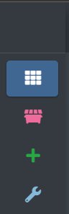 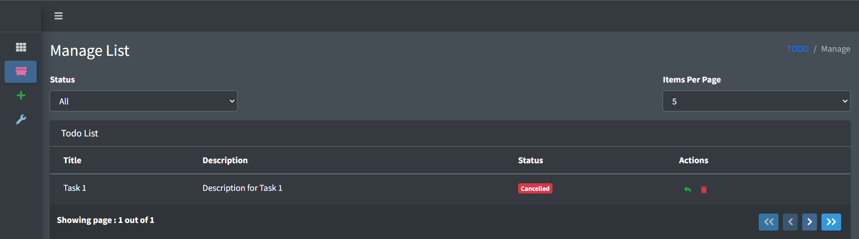
  + To restore the data click the restore task button placed along with the row of task data in the actions column, again there will be a pop-up asking for the confirmation.  
     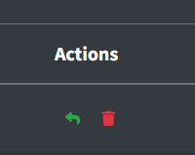 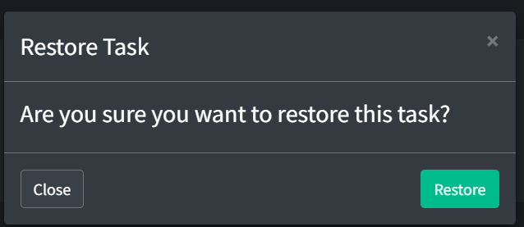
  + Hit the restore button and you can see your task back to your active tasks.
* **VIEW TASKS**
  + Click the view task button placed along with the row of task data in the actions column, then there will be a pop-up showing the current data of your task  
     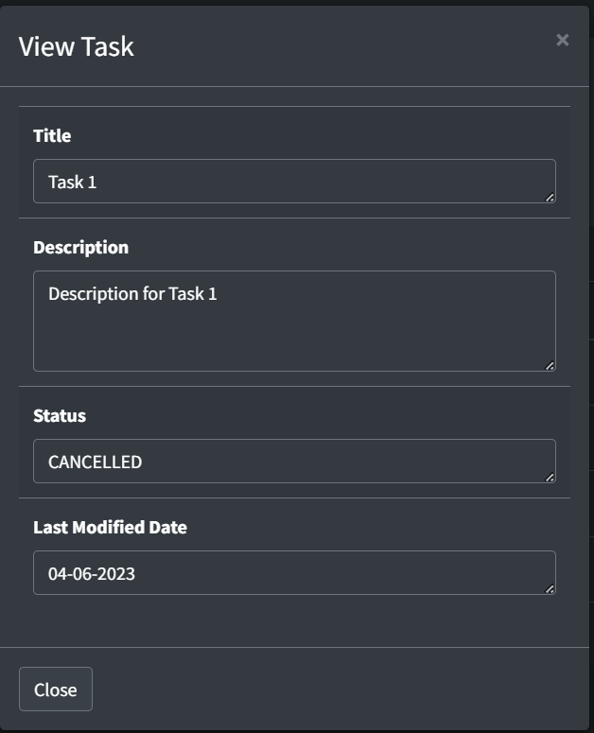
* **TABLE, FILTERS AND PAGINATION**
  + For filtering your tasks you can select a status on status filter and the table will automatically display the tasks accordingly.  
     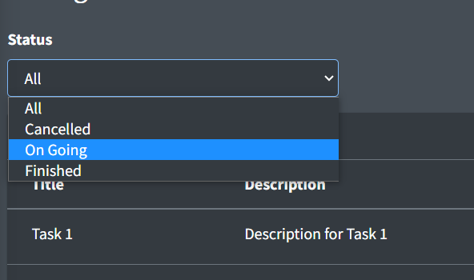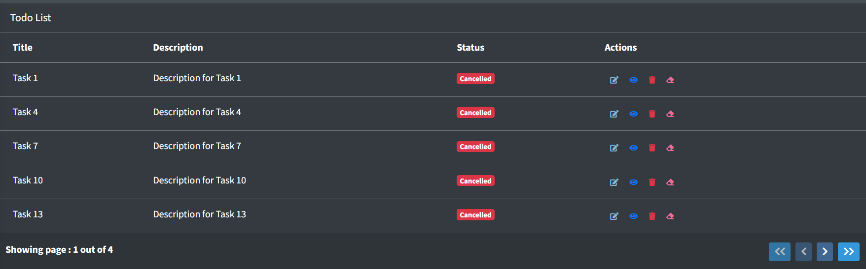
  + For increasing the item per page you can also select from this dropdown and it will update the data inside our table.  
     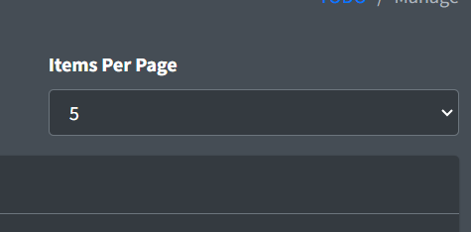
  + To change the page and to check the current page there are buttons controlling which page the table should render, you can also see on the bottom left how many pages are left and which you are in.  
    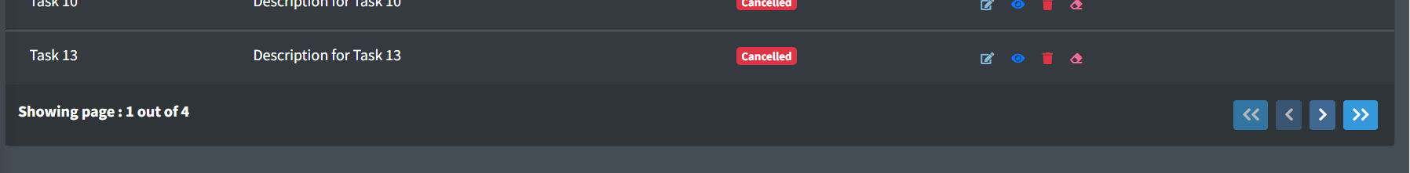
* **TROUBLESHOOTING AND CONFIGURATIONS**
  + You can configure your database creadentials and connections through config page, just click on the configuration button on the sidenav and you will be redirected to config page.  
     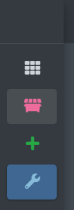 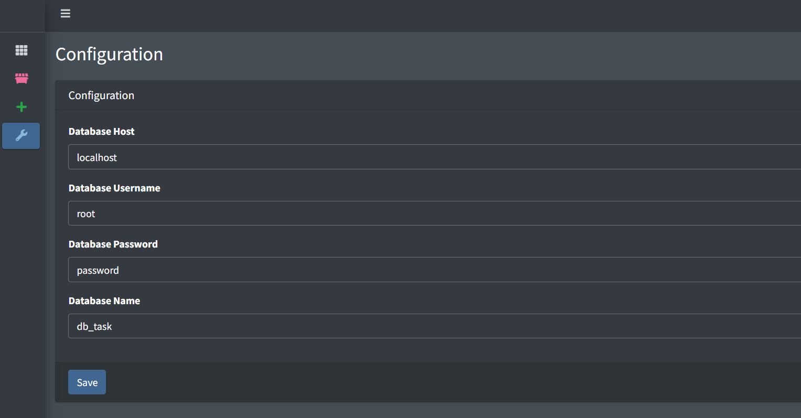
  + Update the configuration and click save the page will reload and will display your new configuraitons.
  + If you are seeing this message in the manage page, kindly go to configurations page and make sure that the provided credentials are correct.  
     